4.4 Exercise 1 – Naming organic compounds II

Name the following organic compounds:

1. 2.
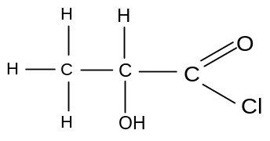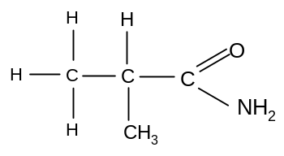

3. 4.
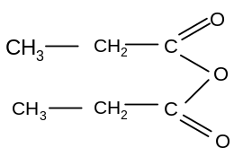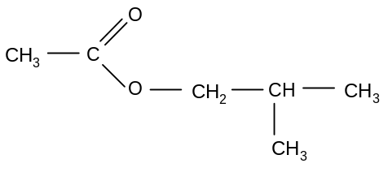

5. 6.
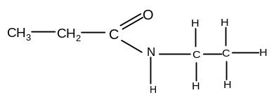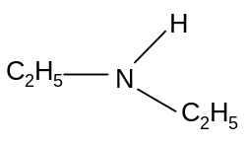

7. 8.
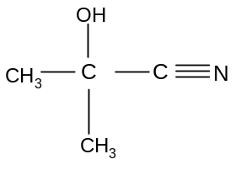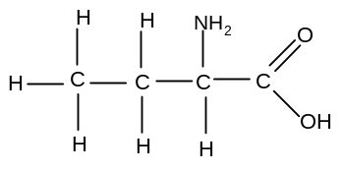

Draw displayed formulae for the following compounds:

9. butanoyl chloride
10. 2-hydroxyethanamide
11. ethanoic butanoic anhydride
12. ethyl 2-hydroxypropanoate
13. N-methylbutanamide
14. N- methyl, N-ethyl, 2-aminobutane
15. sodium 2-hydroxyethanoate
16. ethyldimethylammonium bromide

